Ideation Phase
Define the Problem Statements

Date | 25 MAY 2023
Team ID | NM2023TMID11390
Project Name | IOT based weather adaptive street lightning system
Maximum Marks

Customer Problem Statement:
User from the department of IOT based weather statement.The imaging tool, such as can speed up the identification process. Therefore, our objective is to develop an automated for the detection of solar panel .
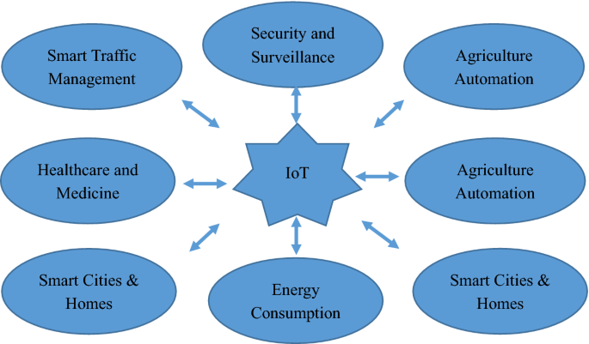

Problem  Statement (PS) | Iam  (Customer) | I’m trying to | But | Because | Which makes me feel

Street lighting | User from the adaptive street light | The imaging tool, such as can solar panel | It consumes lot of time and man | We are recusing the solar enegy | Lights on the streets and areas

